EN 300 718-1 - V1.2.1 Notes

Date: 1/12/2024

Document: https://nhqc3s.hq.nato.int/Apps/ETSI/specs/EN_30071801v010201p.pdf

**General Parameters**

1. Transmitter/receiver with antenna and battery
2. On/off switch with visual indicator
3. Means of conveying information about the received signal to user
4. Commonly used battery with check feature.

**Capable of at least 200 hours of transmitting at a temperature of +10°C and subsequent receiving for 1 hour at a temperature of -10°C, in compliance with the requirements as stated in clauses 8.3 and 9.1.   
**A positive check shall indicate the capability of at least 20 hours of transmitting at a temperature of +10°C

***9.1 not needed because we are not designing a reciver

1. A safety feature against involuntary or accidental leaving of the transmit mode shall be provided in the equipment.
2. The equipment shall include a carrying system that gives the possibility for easy operation and safe placing. The carrying system can be a part of the equipment or an accessory device. The carrying system shall have a joint tensile strength of at least 50 N
3. Operate at 457 kHz in transmit mode
4. Operating instructions shall be delivered with every equipment. They shall cover the following subjects:

a) a statement on avalanche danger;

b) instruction for checking the battery, transmitter and receiver performance and range;

c) instructions for turning on the transmitter and strapping the beacon to the body;

d) instructions for changing to the receive mode and the search strategy (coarse search and fine search);

e) instructions for changing back to the transmit mode, in particular in the case of secondary avalanche;

f) a statement on the temperature sensitivity of essential parts;

g) a statement on the battery lifetime;

h) device-specific measures on a tour.

1. A short form of the operating instructions shall be printed onto the case. The printing shall be clearly visible and abrasion proof. Also, the proper positioning of the batteries shall be indicated
2. The equipment shall be able to operate correctly in the temperature range from -20 to +45°C and shall be stored without damage in the temperature range from -25 to +70°C

**8.3 Output field strength (H-field)**

8.3.1 Definition

The H-field is measured in the direction of maximum field strength under specified conditions of measurement.

8.3.2 Method of measurement

The H-field produced by the equipment shall be measured on the axis of the transmitting antenna at distances of 10 m

on an outdoor test site (see annex A).

**8.3.3 Limits**

8.3.3.1 Minimum transmitted field

The minimum transmitted field strength at 457 kHz shall not be lower than -6 dBµA/m (0,5 µA/m) at a distance of

10 m.

8.3.3.2 Maximum transmitted field

The maximum transmitted field strength at 457 kHz shall not exceed 7 dBµA/m (2,23 µA/m) at a distance of 10 m

**Transmitter Parameters**

1. The carrier keying shall be measured by means of an oscilloscope connected to a suitable coil antenna. The measurements shall be done under normal as well as under extreme test conditions.

1. The carrier frequency shall be measured by means of a test fixture (see clause 6.2). The measurements shall be done under normal as well as under extreme test conditions

**6.2 Test Fixture**

A test fixture may be supplied by the applicant to enable extreme temperature measurements to be made, where applicable. The test fixture shall couple to the generated electromagnetic field from the equipment under test without disturbing the operation of the said device. The test fixture shall be provided with a 50 Ω standard connector, where the generated field can be sampled.

The test laboratory shall calibrate the test fixture by carrying out the required field measurements at normal temperatures at the prescribed test site and then by repeating the same measurements on the equipment under test using the test fixture for all identified frequency components.

The test fixture is only required for extreme temperature measurements and shall be calibrated only with the equipment under test.

**8.4.2 Radiated H-field**

8.4.2.1 Method of measurement (< 30 MHz)

The field strength shall be measured for frequencies below 30 MHz. The equipment under test shall be measured at a distance of 10 m on an outdoor test site. The test antenna shall be a calibrated shielded magnetic field antenna. The equipment under test and test antenna shall be arranged as stated in annex A, clause A.1. The equipment under test shall be switched on in transmit mode (see clause 8.1). The measuring receiver shall be tuned over the frequency range 9 kHz to 30 MHz, except for the frequency band ±20 kHz from the frequency on which the transmitter is intended to operate. At each frequency at which a spurious signal is detected the equipment under test and the test antenna shall be rotated until maximum field strength is indicated on the measuring receiver. This level shall be noted. The limits are quoted in dBµA or dBµA/m, so it is necessary to reduce the reading as explained in annex D for measuring equipment calibrated in dBµV or dBµV/m.

8.4.2.2 Limits

Radiated emissions below 30 MHz shall not exceed the generated H-field at 10 m given in table 2.

A graphical representation is shown in annex B, figure B.1.

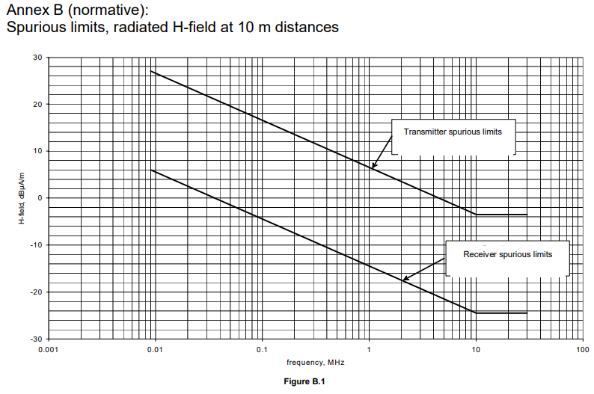

**8.4.3 Effective radiated power**

8.4.3.1 Method of measurement ( 30 MHz)

On a test site, selected from annex A, the equipment shall be placed at the specified height on a non-conducting support and in the position closest to normal use as declared by the applicant. The test antenna shall be oriented for vertical polarization. The output of the test antenna shall be connected to a measuring receiver. The equipment shall be switched on in transmit mode, and the measuring receiver shall be tuned over the frequency range 30 MHz to 1 000 MHz. At each frequency at which a spurious component is detected, the test antenna shall be raised and lowered through the specified range of heights until a maximum signal level is detected on the measuring receiver.

The equipment shall then be rotated through 360° in the horizontal plane, until the maximum signal level is detected by the measuring receiver. The maximum signal level detected by the measuring receiver shall be noted. The substitution antenna shall be oriented for vertical polarization and calibrated for the frequency of the spurious component detected. The frequency of the calibrated signal generator shall be set to the frequency of the spurious component detected. The input attenuator setting of the measuring receiver shall be adjusted in order to increase the sensitivity of the measuring receiver, if necessary. The test antenna shall be raised and lowered through the specified range of heights to ensure that the maximum signal is received. When a test site according to clause A.3 is used, there is no need to vary the height of the antenna. The input signal to the substitution antenna shall be adjusted until an equal or a known related level to that detected from the transmitter is obtained on the measuring receiver. The input signal to the substitution antenna shall be recorded as a power level and corrected for any change of input attenuator setting of the measuring receiver. The measurement shall be repeated with the test antenna and the substitution antenna oriented for horizontal polarization. The measure of the effective radiated power of the spurious components is the larger of the two power levels recorded for each spurious component at the input to the substitution antenna, corrected for the gain of the substitution antenna if necessary.

8.4.3.2 Limits

The power of any radiated emission shall not exceed the values given in table 3.

**10 Measurement uncertainty**

The accumulated measurement uncertainties of the test system in use for the parameters to be measured should not exceed those given in table 6. This is in order to ensure that the measurements remain within an acceptable uncertainty.

